Parish Council Parking Survey Report
Comprehensive analysis of 37 survey responses regarding parking and double yellow lines.

Executive Summary
The survey demonstrates genuine parking concerns, especially on Rose & Crown Hill and Back Lane. However, respondents do not provide majority support for additional double yellow lines. The most common concern is that restrictions would displace parking elsewhere rather than solve the problem.

Key Statistics
Measure | Result
Total responses | 37
Residents in affected area | 33 (89%)
Support yellow lines | 14 (38%)
Oppose yellow lines | 18 (49%)
Most affected location | Rose & Crown Hill
Most common issue | Difficulty passing parked vehicles

Support for Double Yellow Lines
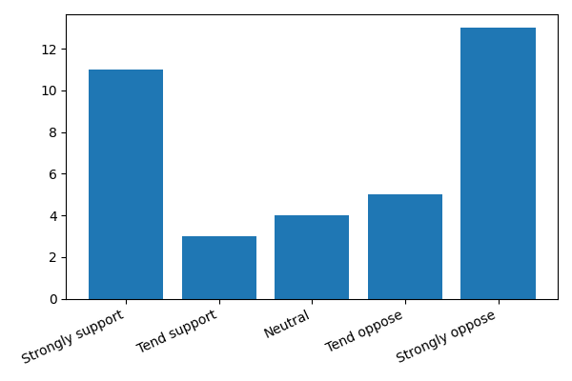

Areas Affected
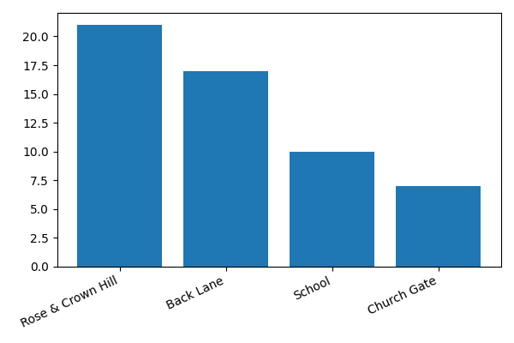

Problems Experienced
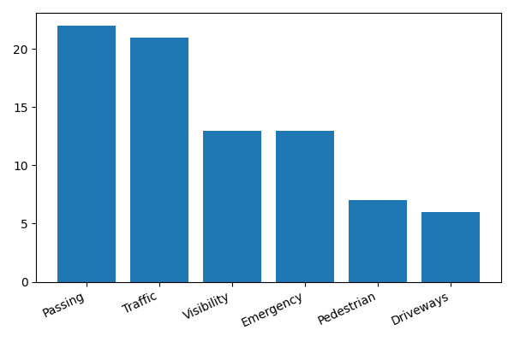

Findings
Parking concerns are concentrated at Rose & Crown Hill and Back Lane. The most frequently reported issues are difficulty passing parked vehicles (22 responses) and traffic obstruction (21 responses). Emergency access and visibility concerns were also significant.

Themes from Written Responses
- Roads are narrow and not designed for modern traffic volumes.
- Yellow lines may simply move parking elsewhere in the village.
- Concerns that additional restrictions could increase vehicle speeds.
- Need to maintain access for emergency and agricultural vehicles.
- Calls for stronger enforcement of existing restrictions.
- Suggestions included 20mph limits, traffic calming, signage and additional parking provision.

Recommendations
- Explore alternative measures before a formal £5,000 application.
- Assess likely parking displacement impacts.
- Review enforcement of existing controls.
- Consider targeted interventions at Rose & Crown Hill and Back Lane.
- Undertake further consultation and public engagement.

Appendix A – Survey Results Summary
Support: 38%; Oppose: 49%; Neutral: 11%.
Most common expected impact: parking displacement (24 responses).
Most supported alternative: signage/road markings (12 responses).

